INDEX

|  |  |  |
| --- | --- | --- |
| Sr. No | Topics | Sign |
| 1 | Design and implement basics embedded circuits  1. Automatic Alarm system- Alarm should get trigger by senor  2. Timer based buzzer  3. Sensor based Counting device |  |
| 2 | Demonstrate communication between two embedded devices using UART port |  |
| 3 | Demonstrate an IoT based game which can be played between two player who are physically at a considerable distance. |  |
| 4 | Develop an IoT application for monitoring water levels in tanks and automatically start the motor to fill the tank if the level goes below the critical level. |  |
| 5 | Develop an IoT module to which measure the intensity of light and send the same to your PC/ Phone |  |
| 6 | Develop an IoT application for Motion detection. |  |

# PRACTICAL NO: 01

**Aim:** Design and implement basics embedded circuits Timer based Counting device.

**Output:**

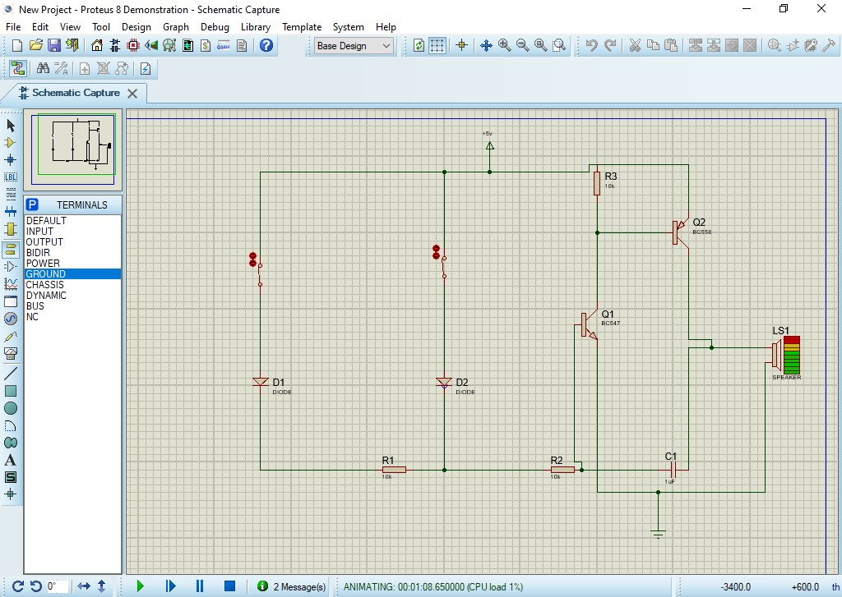

# PRACTICAL NO: 1

**Aim:** Automatic Alarm System –Alarm should get trigger by sensor.

**Output:**

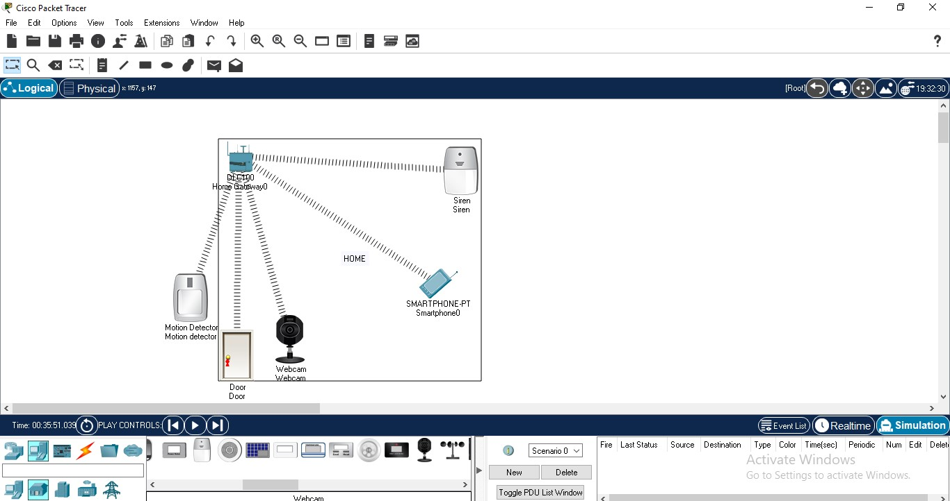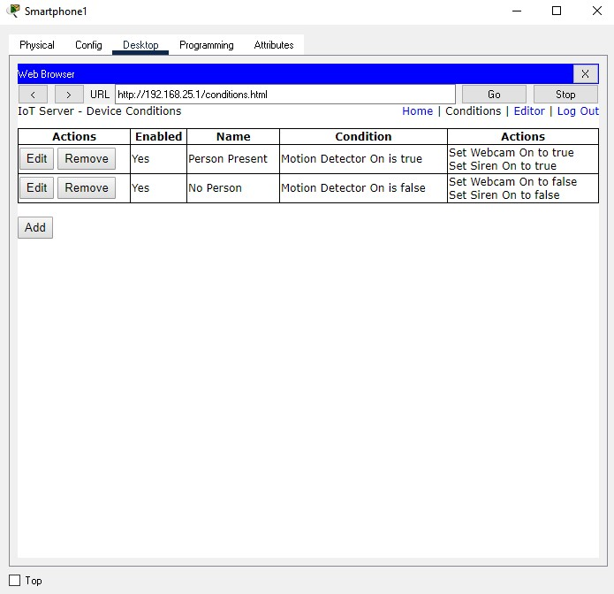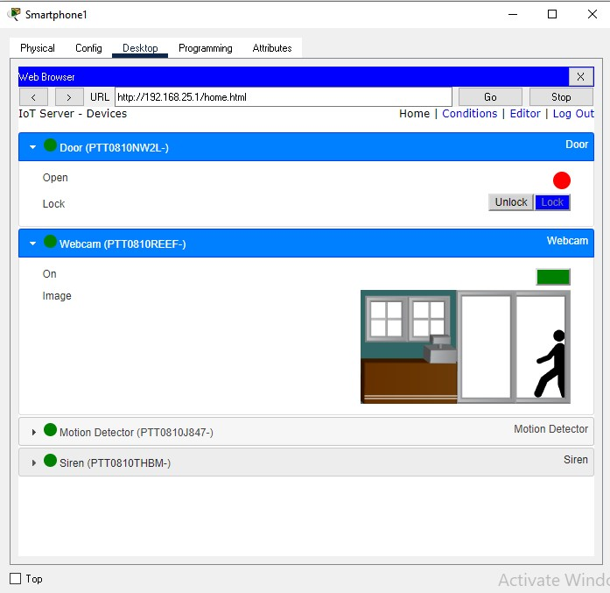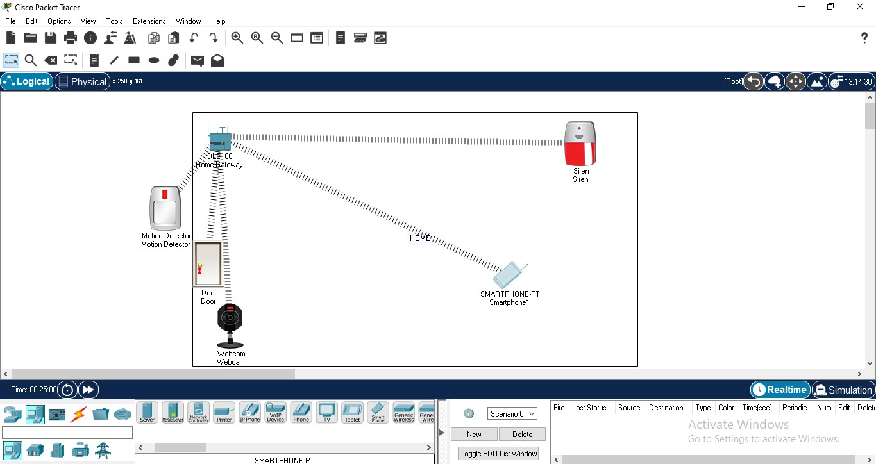

# PRACTICAL NO: 02

**Aim:** Demonstrate communication between two embedded devices using UART port .

**Output:**

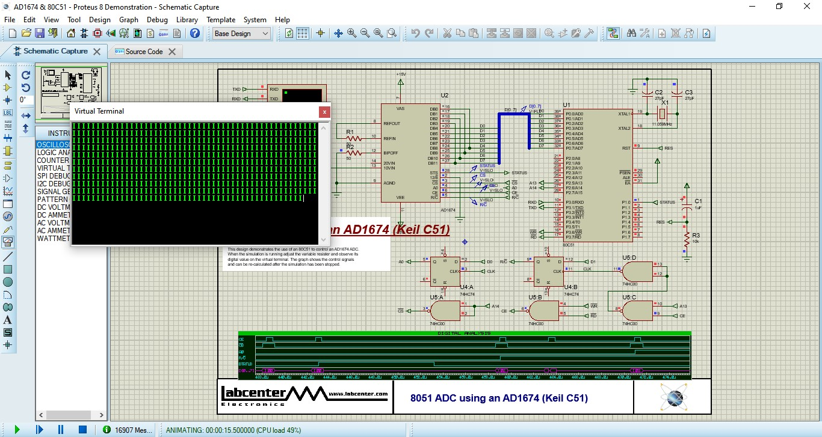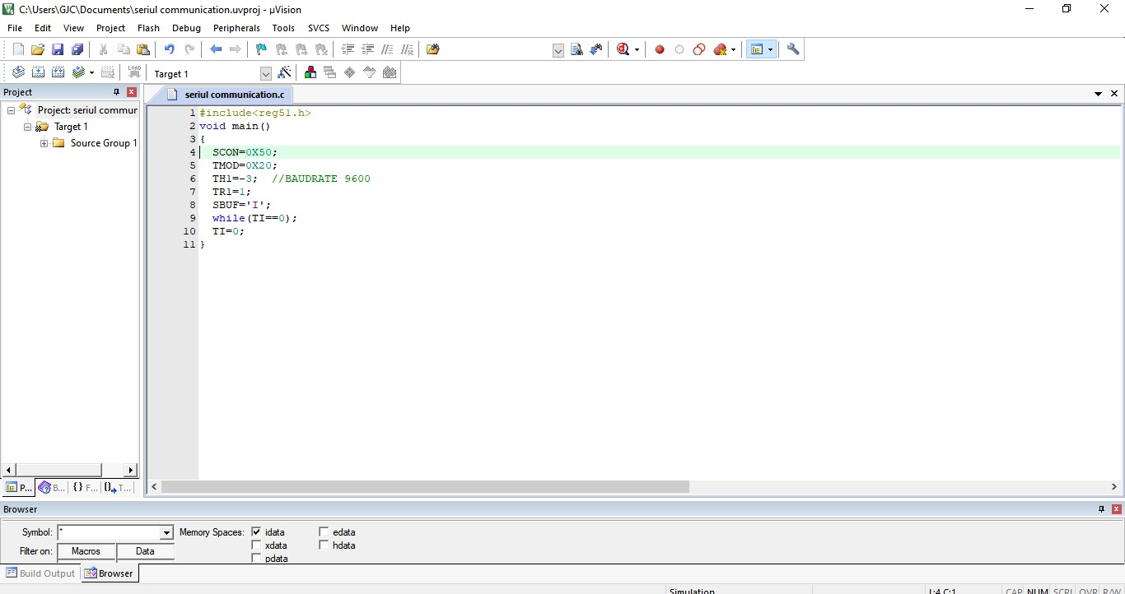

# PRACTICAL NO: 03

**Aim:** Demonstrate an IoT based game which can be played between two player who are physically at a considerable distance.

**Code:** Server.py: import socket # for networking

import pickle # for sending/receiving objects from tic_tac_toe import TicTacToe

HOST = '127.0.0.1' # this address is the "local host" PORT = 12783 # port to listen on for clients s = socket.socket(socket.AF_INET, socket.SOCK_STREAM) s.bind((HOST, PORT))

s.listen(5)

client_socket, client_address = s.accept() print(f"\nConnnected to {client_address}!") player_x = TicTacToe("X") rematch = True while rematch == True:

print(f"\n\n T I C - T A C - T O E ")

while player_x.did_win("X") == False and player_x.did_win("O") == False and player_x.is_draw() == False:

print(f"\n Your turn!") player_x.draw_grid()

player_coord = input(f"Enter coordinate: ") player_x.edit_square(player_coord)

player_x.draw_grid()

x_symbol_list = pickle.dumps(player_x.symbol_list) client_socket.send(x_symbol_list)

if player_x.did_win("X") == True or player_x.is_draw() == True: break

print(f"\nWaiting for other player...") o_symbol_list = client_socket.recv(1024) o_symbol_list = pickle.loads(o_symbol_list) player_x.update_symbol_list(o_symbol_list) if player_x.did_win("X") == True: print(f"Congrats, you won!")

elif player_x.is_draw() == True:

print(f"It's a draw!") else:

print(f"Sorry, the client won.") host_response = input(f"\nRematch? (Y/N): ") host_response = host_response.capitalize() temp_host_resp = host_response

client_response = ""

host_response = pickle.dumps(host_response) client_socket.send(host_response) if temp_host_resp == "N":

rematch = False else:

print(f"Waiting for client response...") client_response = client_socket.recv(1024) client_response = pickle.loads(client_response) if client_response == "N":

print(f"\nThe client does not want a rematch.") rematch = False else:

player_x.restart()

spacer = input(f"\nThank you for playing!\nPress enter to quit...\n") client_socket.close()

**Client.py:** import socket # for networking import pickle # for sending/receiving objects from tic_tac_toe import TicTacToe

HOST = '127.0.0.1' # the server's IP address

PORT = 12783 # the port we're connecting to s = socket.socket(socket.AF_INET, socket.SOCK_STREAM) s.connect((HOST, PORT))

print(f"\nConnected to {s.getsockname()}!") player_o = TicTacToe("O") rematch = True while rematch == True:

print(f"\n\n T I C - T A C - T O E ") player_o.draw_grid() print(f"\nWaiting for other player...") x_symbol_list = s.recv(1024)

x_symbol_list = pickle.loads(x_symbol_list) player_o.update_symbol_list(x_symbol_list) while player_o.did_win("O") == False and player_o.did_win("X") == False and player_o.is_draw() == False:

print(f"\n Your turn!") player_o.draw_grid()

player_coord = input(f"Enter coordinate: ") player_o.edit_square(player_coord)

player_o.draw_grid()

o_symbol_list = pickle.dumps(player_o.symbol_list) s.send(o_symbol_list) if player_o.did_win("O") == True or player_o.is_draw() == True: break

print(f"\nWaiting for other player...") x_symbol_list = s.recv(1024)

x_symbol_list = pickle.loads(x_symbol_list) player_o.update_symbol_list(x_symbol_list) if player_o.did_win("O") == True: print(f"Congrats, you won!") elif player_o.is_draw() == True:

print(f"It's a draw!") else:

print(f"Sorry, the host won.") print(f"\nWaiting for host...") host_response = s.recv(1024)

host_response = pickle.loads(host_response) client_response = "N" if host_response == "Y":

print(f"\nThe host would like a rematch!") client_response = input("Rematch? (Y/N): ") client_response = client_response.capitalize() temp_client_resp = client_response client_response = pickle.dumps(client_response) s.send(client_response)

if temp_client_resp == "Y":

player_o.restart() else: rematch = False else:

print(f"\nThe host does not want a rematch.")

rematch = False

spacer = input(f"\nThank you for playing!\nPress enter to quit...\n") s.close()

**Tic-toc.py:**

class TicTacToe(): def __init__(self, player_symbol):

self.symbol_list = [] for i in range(9):

self.symbol_list.append(" ") self.player_symbol = player_symbol def restart(self): for i in range(9):

self.symbol_list[i] = " " def draw_grid(self):

print("\n A B C\n")

row_one = " 1 " + self.symbol_list[0] row_one += " ║ " + self.symbol_list[1] row_one += " ║ " + self.symbol_list[2] print(row_one) print(" ═══╬═══╬═══") row_two = " 2 " + self.symbol_list[3] row_two += " ║ " + self.symbol_list[4] row_two += " ║ " + self.symbol_list[5] print(row_two) print(" ═══╬═══╬═══") row_three = " 3 " + self.symbol_list[6] row_three += " ║ " + self.symbol_list[7] row_three += " ║ " + self.symbol_list[8] print(row_three, "\n") def edit_square(self, grid_coord): if grid_coord[0].isdigit():

grid_coord = grid_coord[1] + grid_coord[0] col = grid_coord[0].capitalize()

row = grid_coord[1] grid_index = 0 if row == "1": if col == "A": grid_index = 0 elif col == "B": grid_index = 1 elif col == "C": grid_index = 2 elif row == "2": if col == "A": grid_index = 3 elif col == "B": grid_index = 4 elif col == "C": grid_index = 5 elif row == "3": if col == "A": grid_index = 6 elif col == "B": grid_index = 7 elif col == "C": grid_index = 8 if self.symbol_list[grid_index] == " ":

self.symbol_list[grid_index] = self.player_symbol def update_symbol_list(self, new_symbol_list): for i in range(9):

self.symbol_list[i] = new_symbol_list[i] def did_win(self, player_symbol): g = [] for i in range(9):

g.append(self.symbol_list[i]) sym = player_symbol if g[0] == sym and g[1] == sym and g[2] == sym:

return True

elif g[3] == sym and g[4] == sym and g[5] == sym: return True elif g[6] == sym and g[7] == sym and g[8] == sym: return True elif g[0] == sym and g[3] == sym and g[6] == sym: return True elif g[1] == sym and g[4] == sym and g[7] == sym: return True elif g[2] == sym and g[5] == sym and g[8] == sym: return True elif g[2] == sym and g[4] == sym and g[6] == sym: return True elif g[0] == sym and g[4] == sym and g[8] == sym:

return True return False def is_draw(self): num_blanks = 0 for i in range(9): if self.symbol_list[i] == " ":

num_blanks += 1 if self.did_win(self.player_symbol) == False and num_blanks == 0: return True else:

return False

**0utput:**

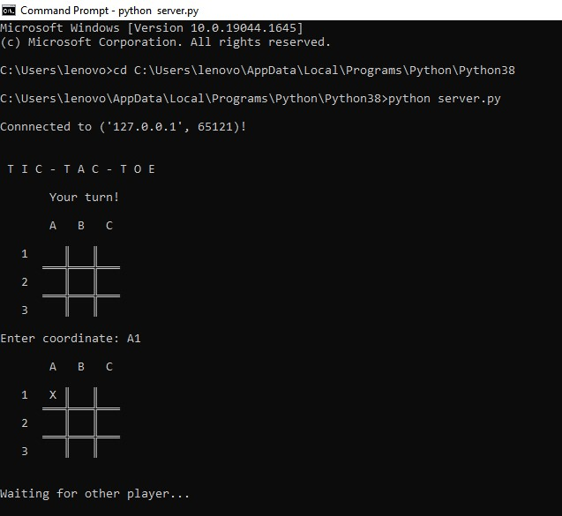

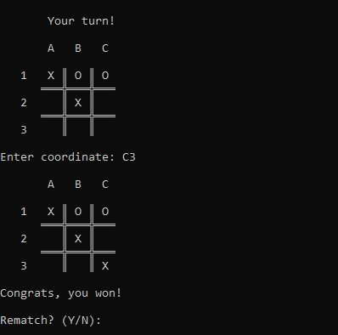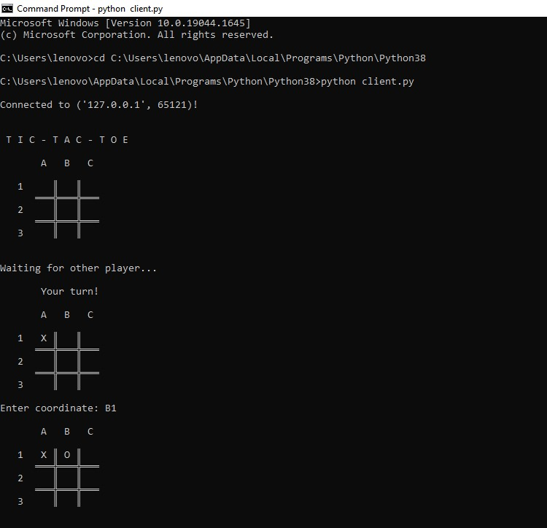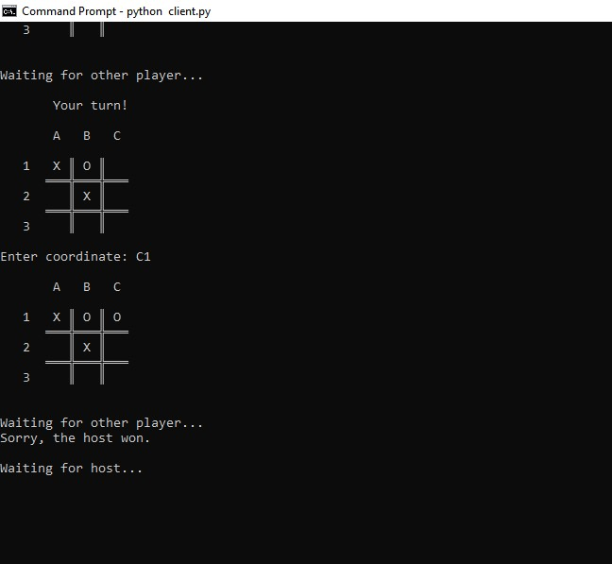

# PRACTICAL NO: 05

**Aim:** Demonstrate an IoT application for monitoring water levels in tanks and automatically start the motor to fill the tank if the level goes below the critical level.

**Output:**

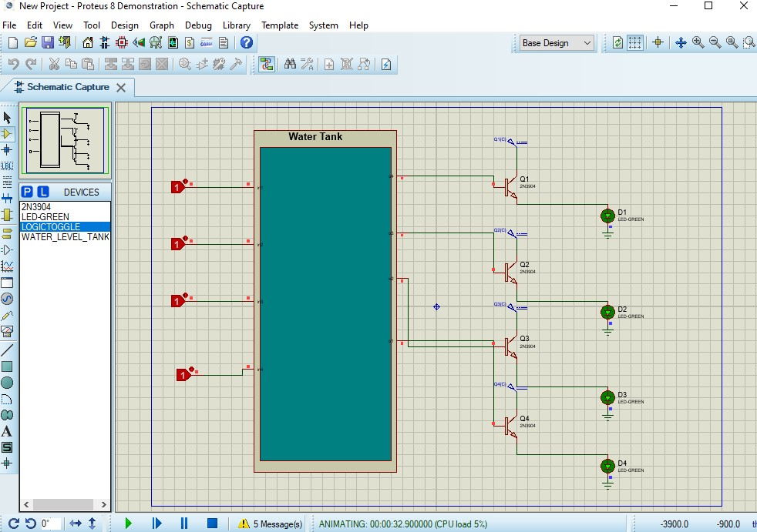

# PRACTICAL NO: 06

**Aim:** Develop an IoT module to which measure the intensity of light and send the same to your PC/Phone.

**Output:**

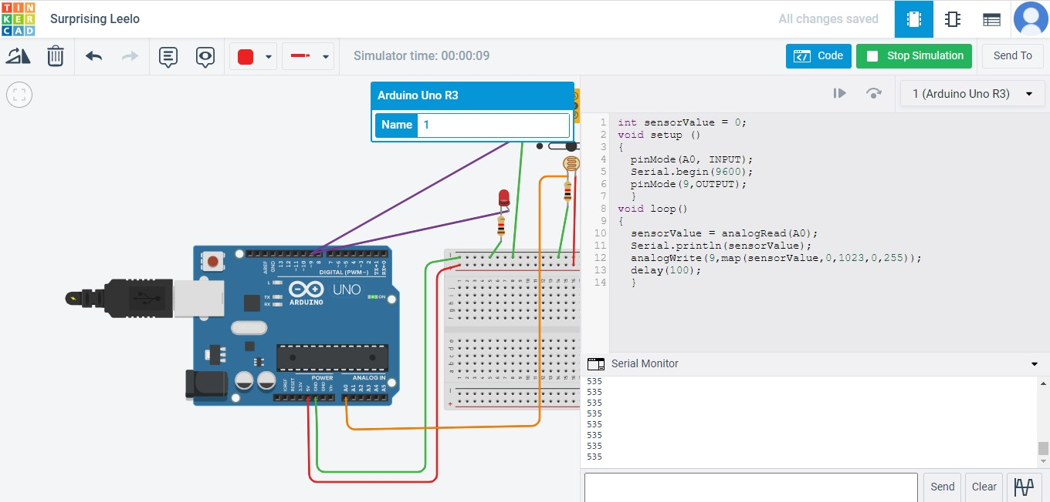

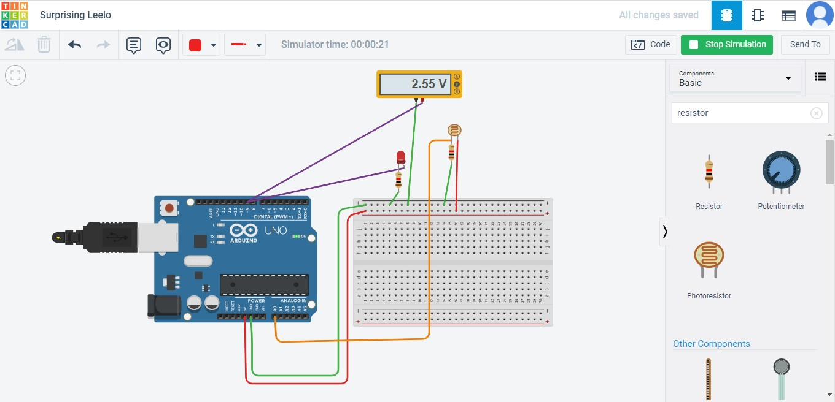

# PRACTICAL NO: 07

**Aim:** Develop an IoT application for Motion detection.

**Output:**

